9/24/2020

C4 Lab

1. Download and install Wireshark software.

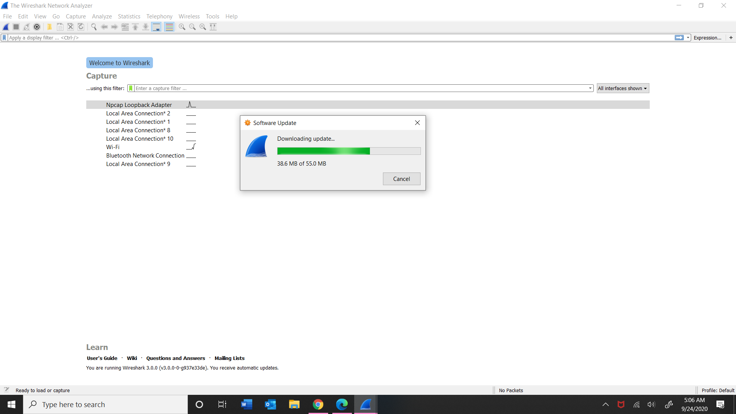

1. I then clicked capture and under interfaces I chose my LAN.

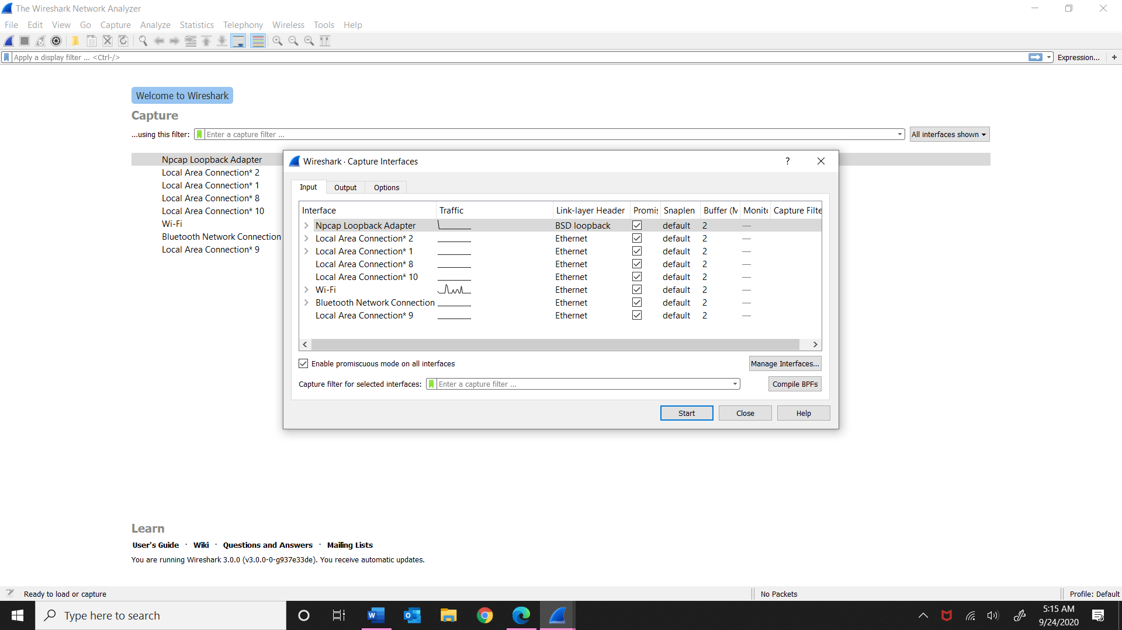

1. I captured all packets and made sure http showed up searching on my web browser. I have the detail information of what I found below.

